January 3, 2017

Dear University of Utah Faculty,

The College of Fine Arts will hold the 7th annual Scholarship Recognition Luncheon on Wednesday, February 22, 2017, at the Beverly Taylor Sorenson Arts & Education Complex. This annual event is an officially sanctioned University activity (Policy 6-100, III, Section 15), and it is an important event for College of Fine Arts scholarship recipients to attend.

We respectfully request that instructors allow the student presenting this letter to miss class and attend this official University event. Of course, the student would be responsible to make up any work missed from the absence.

A copy of this letter is available on the College of Fine Arts website at: Distinguished Alumni (http://www.finearts.utah.edu/alumni/distinguished-alumni)

Thank you for your consideration of this request and your support of our fine students.

Sincerely,

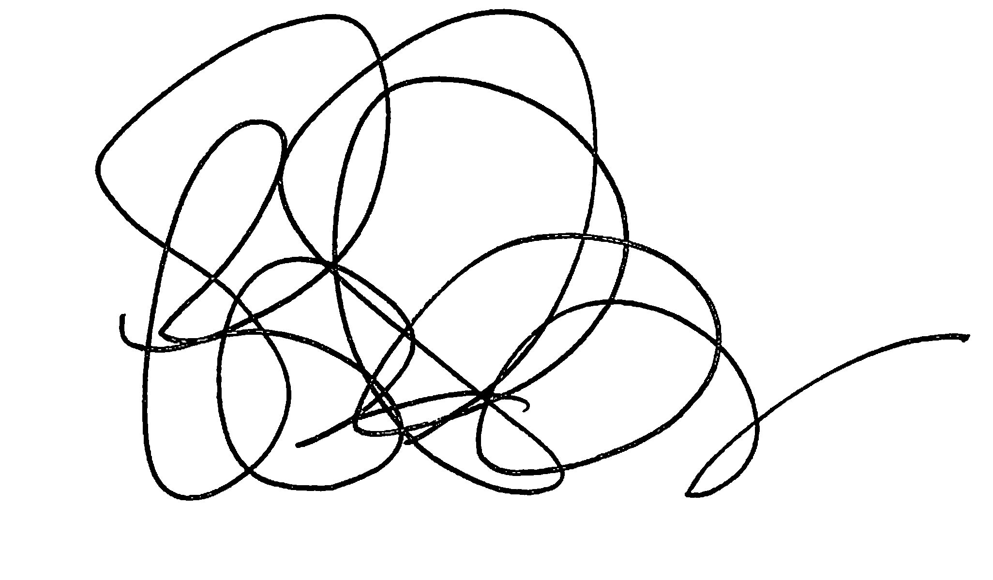
Liz Leckie
Assistant Dean for Undergraduate Affairs
College of Fine Arts

